

Black Falcon 100 Watt Siren
Operating Manual and Installation Instructions

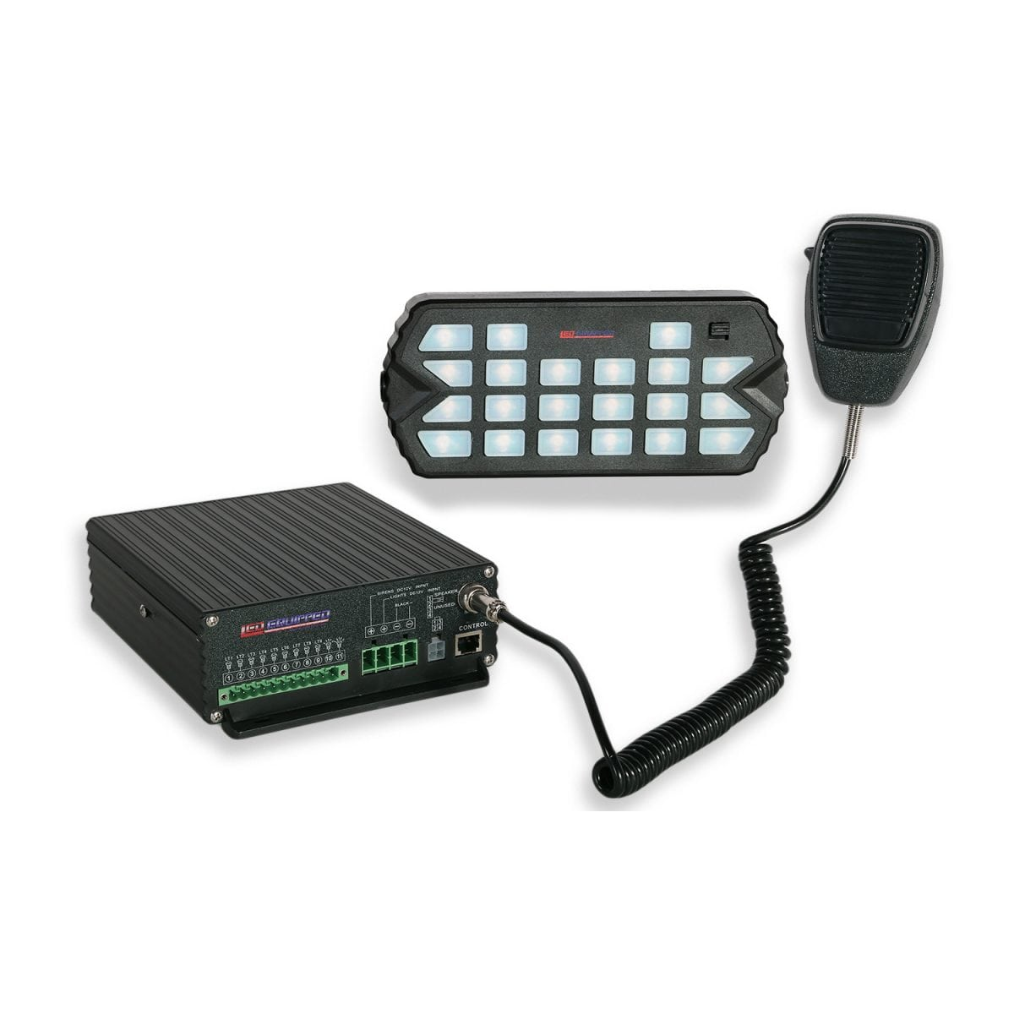
Black Falcon 100 Watt Siren

Operating Manual and Installation Instructions

Warnings and Notices for Users and Installers
WARNING: Take CAUTION when installing
This document must be delivered to and read by the end user and installer as it serves to provide you with the required information for proper and safe use of your LEDEQUIPPED product. Before operating this or any LEDEQUIPPED products the user and installer must read this manual all the way through. You will find important information in this manual that could prevent property damage and/or serious injury to the user and installer. LEDEQUIPPED products are intended to alert pedestrians and other operators of the presence of personnel, the operation of emergency vehicles, an emergency site, and any warning needs. It is your responsibility to make sure you can proceed safely before driving against traffic, entering an intersection, responding to a high rate of speed, or walking on or around traffic lanes.
Your LEDEQUIPPED emergency vehicle devices should be tested daily to insure the device and all it's functions are operating correctly. If you experience a malfunction contact LEDEQUIPPED's Customer Service immediately for troubleshooting options, or a warranty or service claim. You must ensure sure that the projection of the visual and audible is not blocked by vehicle components (i.e.: open trunks, visors, compartment doors), vehicles, other obstructions, or people. LEDEQUIPPED's sirens and other audible devices project sound in a forward direction and should be installed in a forward direction that faces away from the occupants of the vehicle.

This is professional grade equipment and is intended for strict use by authorized personal only. It is the user's responsibility to understand and obey all laws regarding emergency warning devices. You must know and be familiar with all applicable city, sate, and federal laws and regulations prior to the use of emergency vehicle warning devices. LEDEQUIPPED assumes no liability for any loss resulting from the use of this warning device. Proper installation is vital to the performance of the warning devices and safe operation of the emergency vehicle. Since the operator is under stressful environments the equipment must be properly wired and mounted to ensure effectiveness and safety. Therefore, controllers must be properly installed and placed within convenient reach of the operator so eye contact with the roadway is never lost. The effectiveness of your LEDEQUIPPED equipment is highly dependent upon correct mounting and wiring.

Improper wiring and mounting of the warning device will reduce the output and performance of the equipment. Emergency warning devices frequently require high electrical voltages and/or currents. Properly protect and use caution around live electrical connections. Grounding or shorting of electrical connections can cause high current arcing, which can cause severe personal injury and/or serious vehicle damage, including fire. Electromagnetic interference can be caused by many electronic devices used in emergency vehicles. To ensure that this doesn't happen to you, lights bars should be mounted a minimum of 12" - 34" from the radio antenna and do not power your equipment from the same circuit or share the same grounding circuit with radio communication equipment. After installation test all the vehicles equipment together to ensure everything operates free of interference. Driver and/or passenger airbags bags (SRS) will impact the way you mount your equipment. Any equipment installed in the deployment area of the airbags will damage or dislodge the airbags and sensors. This will also reduce the effectiveness of the airbags to protect the passengers and therefore these areas must be avoided. Installers must make sure that this equipment along with any parts, hardware, wiring, power supplies, and switch boxes do not interfere with the airbags, SRS wiring, or sensors. All LEDEQUIPPED equipment needs to be mounted and installed according to the vehicle manufactures instructions and securely attached to a part of the vehicle of sufficient strength to withstand the forces applied to the equipment. This device should be permanently mounted within the zones specified by the vehicle manufactures. This especially applies to equipment mounted on the exterior of the vehicle to avoid dislodging. When mounting units on the interior of the vehicle by a method other than permanent mount is discouraged as the it may become to detached under aggressive driving conditions such as sudden breaking, collision, or swerving.

Important Points for Your Safety and Longevity of your Equipment
Installers are required to have a good understanding of automotive electronic, systems and procedures for proper installation.
- One should not stare directly into the LEDs as momentary blindness and/or eye damage may occur.
- One should not take any lights through a car wash. Use only water to clean the outer body/lens of your equipment. –
- One should not use a pressure washer to clean any LEDEQUIPPED products. Inspect and test your product daily to insure it operates properly and is mounted correctly.
- One should not cut wires or work on a unit while the unit is still connected to a power source.
- One should not install this product or rout any wires through or in the deployment area of the airbag. Doing so may cause serious personal injury as it will damage or reduce the effectiveness of the airbag by causing the unit to become a projectile.
Reference the owner's manual for your vehicle to find the airbag deployment area. The User/Installer assumes all responsibility to determine proper mounting location, based on providing ultimate safety to all passengers in the vehicle.
- If the product requires you to drill holes the installer must ensure that the drilling process does not damage any vehicle components or other vital parts. Check all sides of the mounting surface before beginning to drill. Make sure to deburr all drilled holes and remove any metal remnants or shards to avoid injury and wires from becoming spliced. Grommets are to be installed in all wire passage holes.
- For LEDEQUIPPED products to operate at optimum efficiency a secure and good electrical connection to the Batteries Ground Post must be made. The recommended procedure requires the unit's ground wire be connected directly to the NEGATIVE (-) battery post.
Accessories
The following parts are included with the Black Falcon 100w Siren.

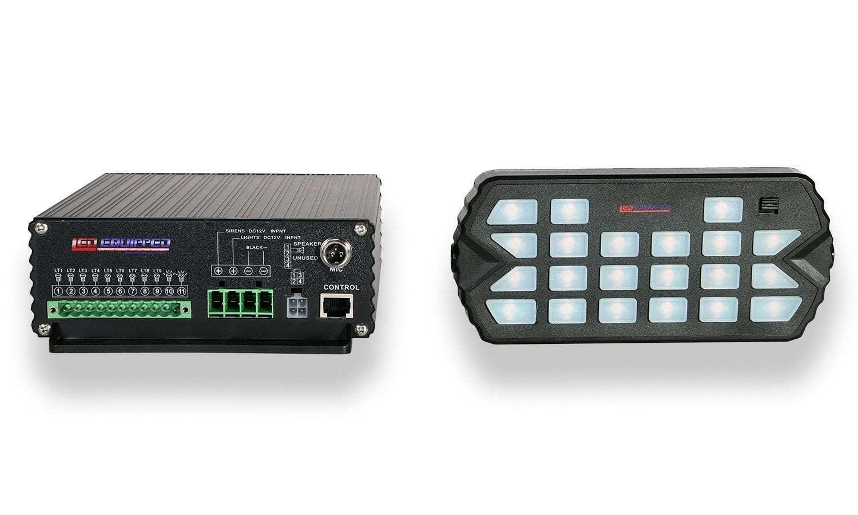
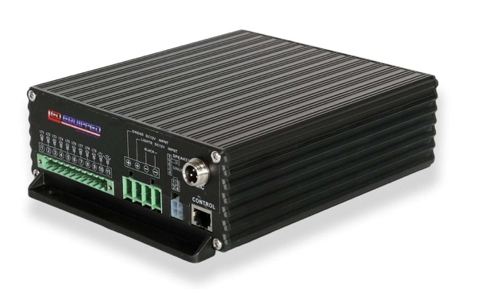

Black Falcon 100w Siren Amplifier |  | Siren and Accessory Control Unit
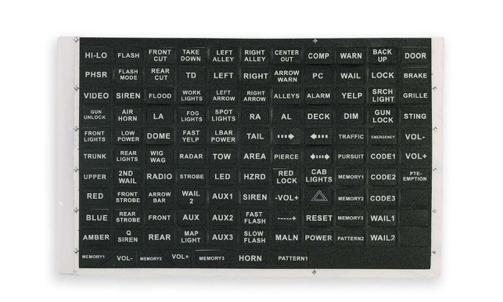

PA Microphone |  | Black Falcon Control Unit Sticker Sheet
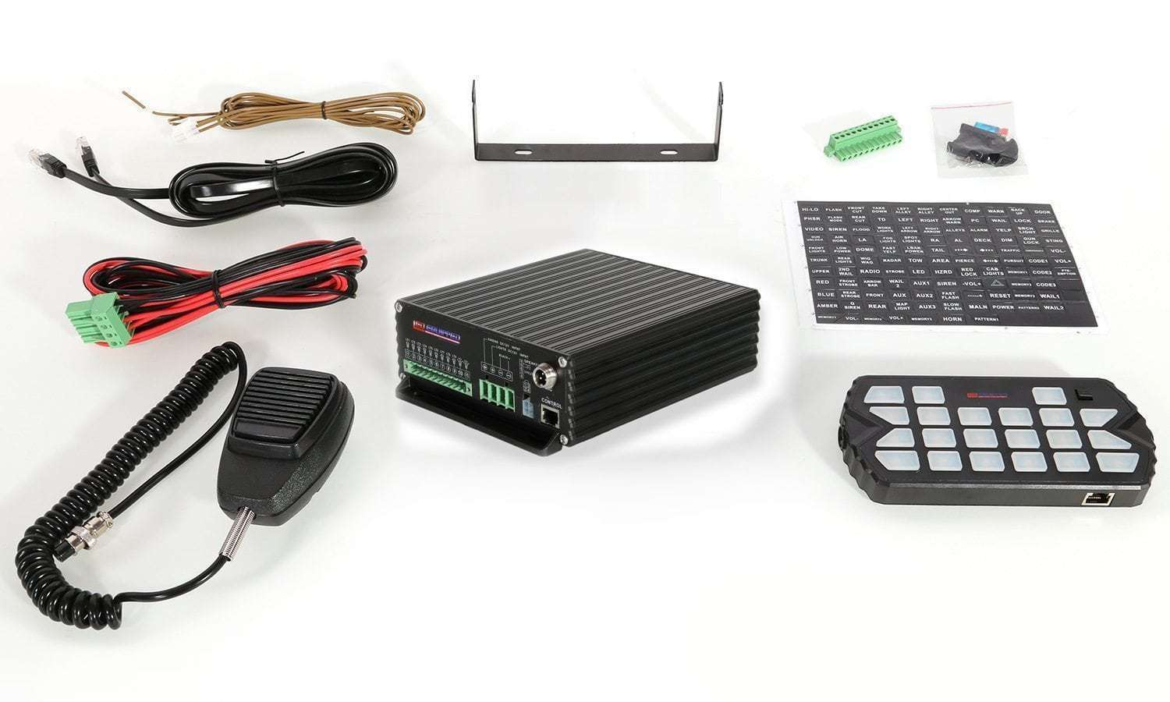

RJ45 Control Unit Cable |  | Control Unit Mounting Bracket
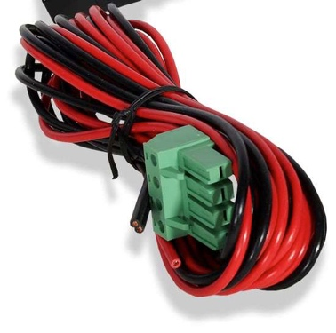
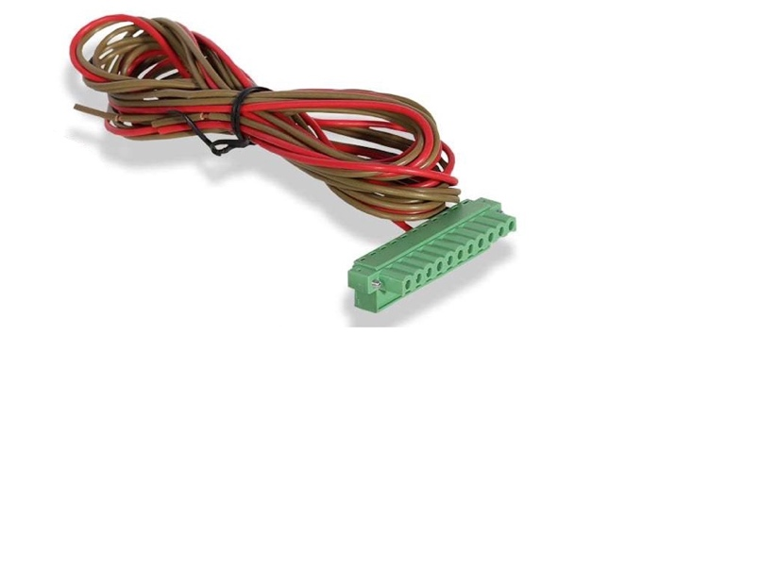

Four (4) Pin 12v Power Wiring Harness |  | Eleven (11) Pin Siren and Accessory Control

Spare Fuses and PA Microphone Mounting Bracket

Instructions for Wiring and Operation

Installation and Wiring
To ensure proper installation installers are required to have a good understanding of automotive electronic, systems and procedures for proper installation.
When you are drilling into the vehicle's surfaces, ensure that the area is free of any electrical wires, vehicle upholstery, fuel lines, etc. that could be damaged. All wiring passing through drilled holes should use grommets and silicone sealant to prevent wire or moisture damage when passing through compartment walls.
WARNING! Larger wires and secure or tight connections will ensure longer service life for your product. It is highly recommended that soldered connections have heat shrink used to protect the connection. Special attention should be given to the location and method of splicing wires to make electrical connections to protect these splices from lost power or connection and corrosion.
Insulation displacement connectors are not to be used. To reduce voltage drop, minimize the number of splices in the wires. The current carrying capacity of wires and fuses will be significantly reduced under high ambient temperature (e.g. under the hood).
All wires should be in accordance with the minimum wire size and other recommendations made by the manufacturer and be protected from hot surfaces and moving parts. Grommets, cable ties, looms, and other installation hardware should be used to anchor and protect all wiring. Fuses should be properly sized and located as close to the power take off points as possible to protect the wiring and device. To protect against short circuits, a fuse is included by LEDEQUIPPED for all products. Do NOT use a fuse with a higher amp rating than the initial fuse included.

Fig. 1

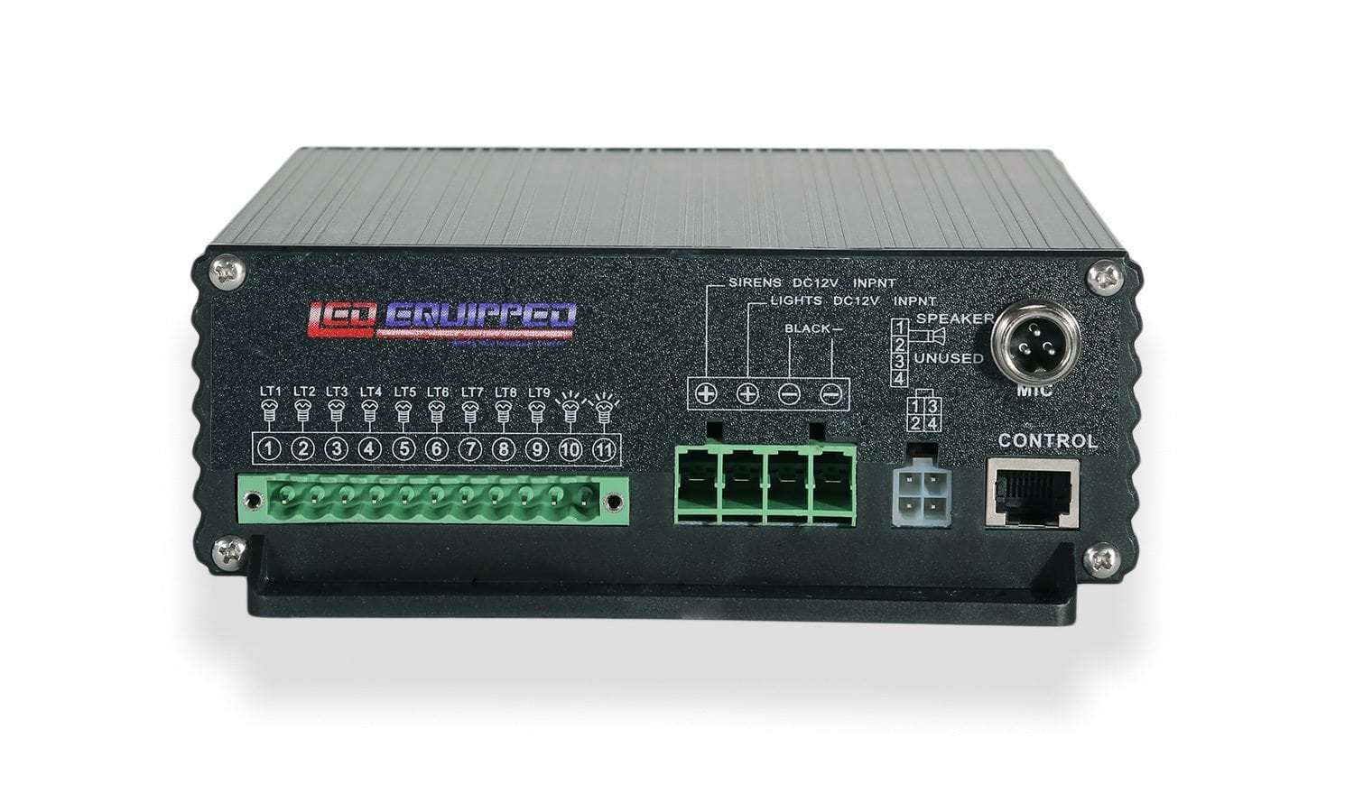

The Black Falcon 100w Siren is designed for easy connection to your vehicle and comes with prewired 12v+ and 12v- power wires. All wiring for the Black Falcon 100w Siren is connected using the provided eleven (11)-pin and four (4)-pin wiring harnesses using screw down wire terminals for ease of installation. (Fig. 1). In addition to the provided wiring harnesses, the Black Falcon 100w Siren’s handheld control is connected using a preinstalled RJ-45 connector and controller input.

Wiring the Black Falcon 100 Watt Siren

Wiring the Black Falcon 100w Siren is made easy through the use of screw down wire terminals. Please note that the 12v + (Positive/Red Wires) and 12v – (Negative/Black Wires) wiring connections must be made to an appropriate 12v power source and ground, in order for your Black Falcon 100w Siren to function properly. The images included below provides a visual representation for how to wire the four (4) pin power and ground wire harness (Figure 2), the eleven (11) pin Black Falcon 100w Siren wiring harnesses (Figure 3), and four (4) pin siren speaker wiring harness (Figure 4).

Fig. 2

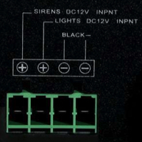

Four (4) Pin Power and Ground Wire Harness
Terminal | Function
Sirens DC 12v INPNT | 12v + (Positive) – For Siren Installation
Lights DC 12v INPNT | 12v + (Positive) – For Accessory Installation (Lights)
Black – | 12v – (Negative)

Fig. 3

Eleven (11) Pin Wire Harness
Terminal | Function
LT1 (1) | 12v + (Positive) Output – For Accessory (Light) L1
LT2 (2) | 12v + (Positive) Output – For Accessory (Light) L2
LT3 (3) | 12v + (Positive) Output – For Accessory (Light) L3
LT4 (4) | 12v + (Positive) Output – For Accessory (Light) L4
LT5 (5) | 12v + (Positive) Output – For Accessory (Light) L5
LT6 (6) | 12v + (Positive) Output – For Accessory (Light) L6
LT7 (7) | 12v + (Positive) Output – For Accessory (Light) L7
LT8 (8) | 12v + (Positive) Output – For Accessory (Light) L8
LT9 (9) | 12v + (Positive) Output – For Accessory (Light) L9
Momentary 1 (10) | 12v + (Positive) Output – Momentary Switch - 1
Momentary 2 (11) | 12v + (Positive) Output – Momentary Switch - 2

Fig. 4

Four (4) Pin Speaker Wire Harness*
Terminal | Function
1 | Speaker + (Positive)
2 | Speaker - (Negative)
3 | Unused
4 | Unused

*Please note that the four (4) pin speaker wire harness comes prewired with four (4) feet of speaker connection wire to terminals 1 and 2 for ease of connection to the external siren speaker.

Black Falcon 100 Watt Siren Wiring Diagram

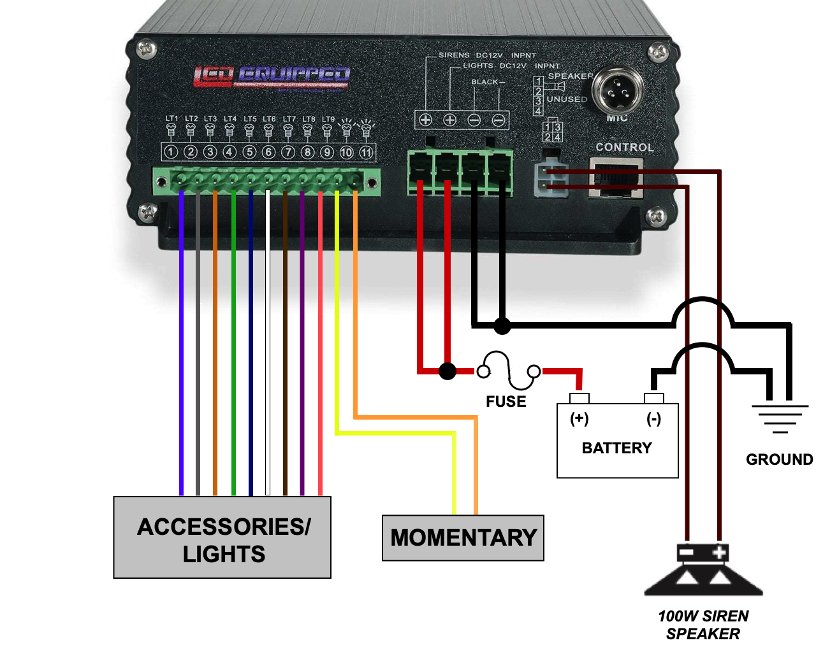

All wiring connections should be secured using appropriate automotive connectors or through the use of soldered connections. All connections should be protected by using heat shrink wire wrap in order to protect the connection. Special attention should be given to the location and method of splicing wires to make electrical connections to protect these splices from lost power or connection and corrosion.

Connecting the Black Falcon 100w Siren and Accessory Control Unit

The Black Falcon 100w Siren and Accessory Control Unit is designed to use a standard RJ45 connection to connect to the Black Falcon 100w Siren Amplifier. Simply plug in the provided RJ45 Control Unit Cable to the Siren and Accessory Control Unit as well as the ‘Control’ port on the Black Falcon 100w Siren Amplifier to connect the unit. Additional RJ45 extension cable can be purchased for installations requiring longer runs. This provided RJ45 Control Unit Cable and optional extension cable can be used to extend the reach of your Siren and Accessory Control Unit so that the Black Falcon 100w Siren Amplifier can be mounted anywhere within your vehicle.

Mounting the Black Falcon 100w Siren Amplifier Unit

The Black Falcon 100w Siren is designed to be mounted directly into your preferred vehicle location. There are four (4) mounting holes on the Black Falcon 100w Siren amplifier unit, which should be used to secure the unit to your vehicle in your preferred vehicle location. Please ensure that before mounting or drilling holes in your vehicle to mount the unit, that the area for mounting is clear of any vehicle wiring components and that the unit is mounted in such a way that it will not interfere with any of your vehicle’s safety components, including Air Bags. As noted above, included with the Black Falcon 100w Siren is an RJ45 extension cable that can be used to extend the reach of your handheld remote control unit from the mounting location of the Black Falcon 100w Siren amplifier unit.

Operation

The Black Falcon 100w Siren includes a lighted Siren and Accessory Control Unit to operate both the optional accessories/lights as well as the included siren and horn tones. There are nine (9) soft touch buttons to operate those accessories/lights that you may choose to control using the Black Falcon 100w Siren (LT1 – LT9). In addition, there are five (5) soft touch buttons to operate each of the included siren and horn tones that are included with your Black Falcon 100w Siren. Three (3) memory buttons are included to allow for customized control of multiple lights and accessories as well as siren tones. In addition, two (2) momentary buttons are for use in wiring accessories/lights that require the use of a momentary button that does not remain active when depressed. The main ‘Power’ switch allows for quickly and easily powering the entire unit on and off.

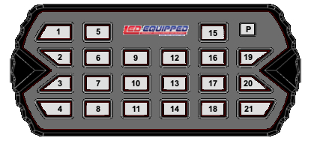

The respective button functions are:

P Power on and power off of the Black Falcon 100w Siren and Accessories/Lights.
1 Horn - Air Horn Tone.
2 Volume (+) - Volume up button increases the output volume of the Black Falcon 100w Siren.
3 Volume (-) - Volume down button decreases the output volume of the Black Falcon 100w Siren.
4 Momentary button – for use in wiring accessories/lights that require the use of a momentary button that does not remain active when depressed. In many cases, this button would be used to hard wire a pattern selection function for one or more accessories/lights.
5 Wail - Holding this button will allow the Wail siren tone to reach its peak and hold that tone until this button is released. This is a manual use function and does not engage a constant siren tone.
6 Mech - Mechanical Siren Tone.
7 Yelp - Yelp Siren Tone.
8 PHSR - Phaser Siren Tone.
9 Individual control for discrete accessories/lights that can be controlled by the Black Falcon 100w Siren and Accessory Control Unit. Accessories/lights wired to terminal LT1 (1) on the eleven (11) pin wire harness are controlled using this button.
10 Individual control for discrete accessories/lights that can be controlled by the Black Falcon 100w Siren and Accessory Control Unit. Accessories/lights wired to terminal LT4 (4) on the eleven (11) pin wire harness are controlled using this button.
11 Individual control for discrete accessories/lights that can be controlled by the Black Falcon 100w Siren and Accessory Control Unit. Accessories/lights wired to terminal LT7 (7) on the eleven (11) pin wire harness are controlled using this button.
12 Individual control for discrete accessories/lights that can be controlled by the Black Falcon 100w Siren and Accessory Control Unit. Accessories/lights wired to terminal LT2 (2) on the eleven (11) pin wire harness are controlled using this button.
13 Individual control for discrete accessories/lights that can be controlled by the Black Falcon 100w Siren and Accessory Control Unit. Accessories/lights wired to terminal LT5 (5) on the eleven (11) pin wire harness are controlled using this button.
14 Individual control for discrete accessories/lights that can be controlled by the Black Falcon 100w Siren and Accessory Control Unit. Accessories/lights wired to terminal LT8 (8) on the eleven (11) pin wire harness are controlled using this button.
15 Momentary button – for use in wiring accessories/lights that require the use of a momentary button that does not remain active when depressed. In many cases, this button would be used to hard wire a pattern selection function for one or more accessories/lights..
16 Individual control for discrete accessories/lights that can be controlled by the Black Falcon 100w Siren and Accessory Control Unit. Accessories/lights wired to terminal LT3 (3) on the eleven (11) pin wire harness are controlled using this button.
17 Individual control for discrete accessories/lights that can be controlled by the Black Falcon 100w Siren and Accessory Control Unit. Accessories/lights wired to terminal LT6 (6) on the eleven (11) pin wire harness are controlled using this button.
18 Individual control for discrete accessories/lights that can be controlled by the Black Falcon 100w Siren and Accessory Control Unit. Accessories/lights wired to terminal LT9 (9) on the eleven (11) pin wire harness are controlled using this button.

19 Memory Button 1 – Programmable memory function allow for customized control of multiple lights and accessories as well as siren tones. Depressing the desired memory button will activate each of the preprogrammed lights and accessories. Please see below for memory button programming instructions.
20 Memory Button 2 – Programmable memory function allow for customized control of multiple lights and accessories as well as siren tones. Depressing the desired memory button will activate each of the preprogrammed lights and accessories. Please see below for memory button programming instructions.
21 Memory Button 3 – Programmable memory function allow for customized control of multiple lights and accessories as well as siren tones. Depressing the desired memory button will activate each of the preprogrammed lights and accessories. Please see below for memory button programming instructions.
The Black Falcon 100w Siren and Accessory Control Unit is equipped with an LED backlight which changes color to illuminate the current functions that are in use.

Memory Button Programming Instructions

The Black Falcon 100w Siren and Accessory Control Unit includes three (3) individually programmable memory buttons that allow for customized control of multiple lights and accessories as well as siren tones. Depressing the desired memory button will activate each of the preprogrammed lights and accessories.

To program each individual memory button follow the steps below:

- Make sure that the Siren and Accessory Control Unit is powered on.
- Press the desired memory button for programming.
- Select and activate the individual accessories/lights and siren tones that will be activated using the desired memory button. If an individual accessory/light and/or siren tone is selected in error, press the button again to turn it off before proceeding.
- After selecting all the desired accessories/lights and siren tones that that will be activated using the selected memory button, press and hold the desired memory button for three (3) seconds, until the Siren and Accessory Control Unit emits a beep signal. This indicates that the selected accessories/lights and siren tones are now programmed to the selected memory button.
- Repeat steps one (1) through four (4) to program the additional two (2) included memory buttons.

**Please note that if the Siren and Accessory Control Unit is powered off while the memory functions are in use, the programmed memory functions will recall the last programmed functions only once. To prevent a loss of programmed memory functions, manually depress the memory button, or the individual accessory/light and siren control buttons to turn off each activated function, prior to powering off the Siren and Accessory Control Unit.

Black Falcon 100w Siren Optional Accessories

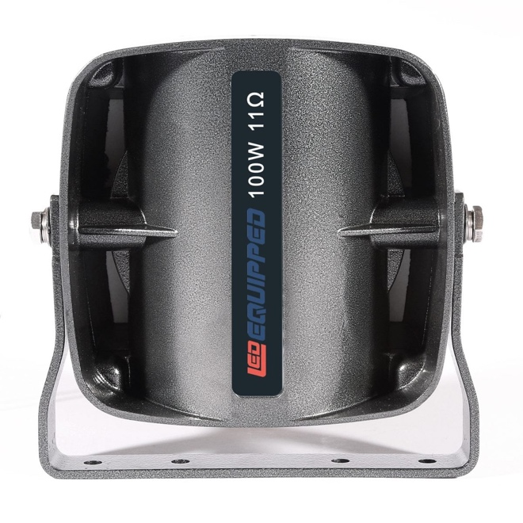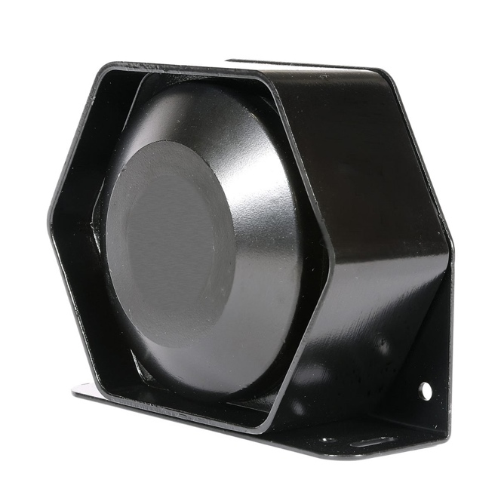
American Pipit 100w Siren Speaker  (Product Number: A-1120) | Frightener 100w Siren Speaker  (Product Number: A-1262)

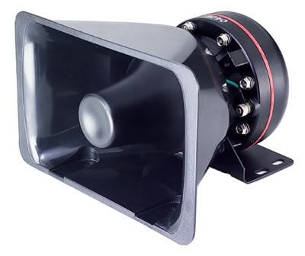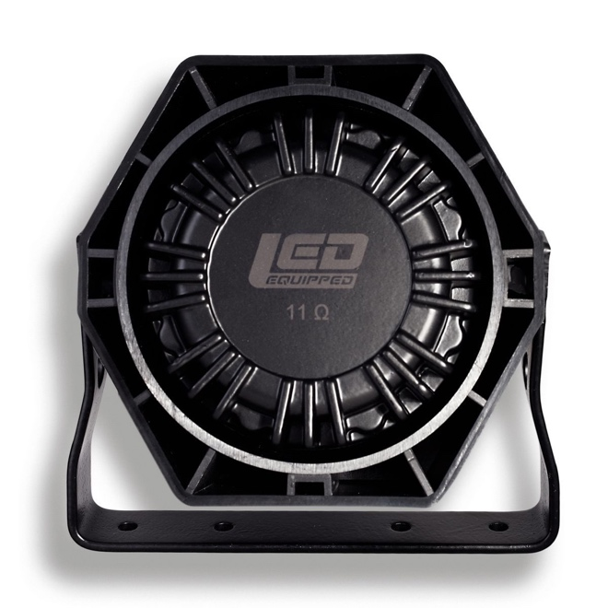
Mocking 100w Siren Speaker  (Product Number: A-1112) | Norther Shrike 100w Siren Speaker  (Product Number: A-1121)

At LEDEQUIPPED, we know that you need affordable lighting for your police, EMS, fire, construction, or towing vehicles and that safety and reliability are important to you. That’s why all of our LED products feature powerful up do date Generation LED lighting, perfect for your police, fire, construction, or EMS vehicle. LEDEQUIPPED focuses on a mission to carry out business ethically and with integrity, provide powerful products of the highest quality, maintain excellent and affordable prices, and to establish an unparalleled customer service relationship beginning with establishing trust with our costumers. As a provider of emergency vehicle lighting, we value the honesty, professionalism, and expertise present within our customer base
For any questions regarding our products, contact us by calling us at +1 800-846-3940 or email us at sales@ledequipped.com.

