

NightHawk Series LED Running Board Lights
Operating Manual and Installation Instructions

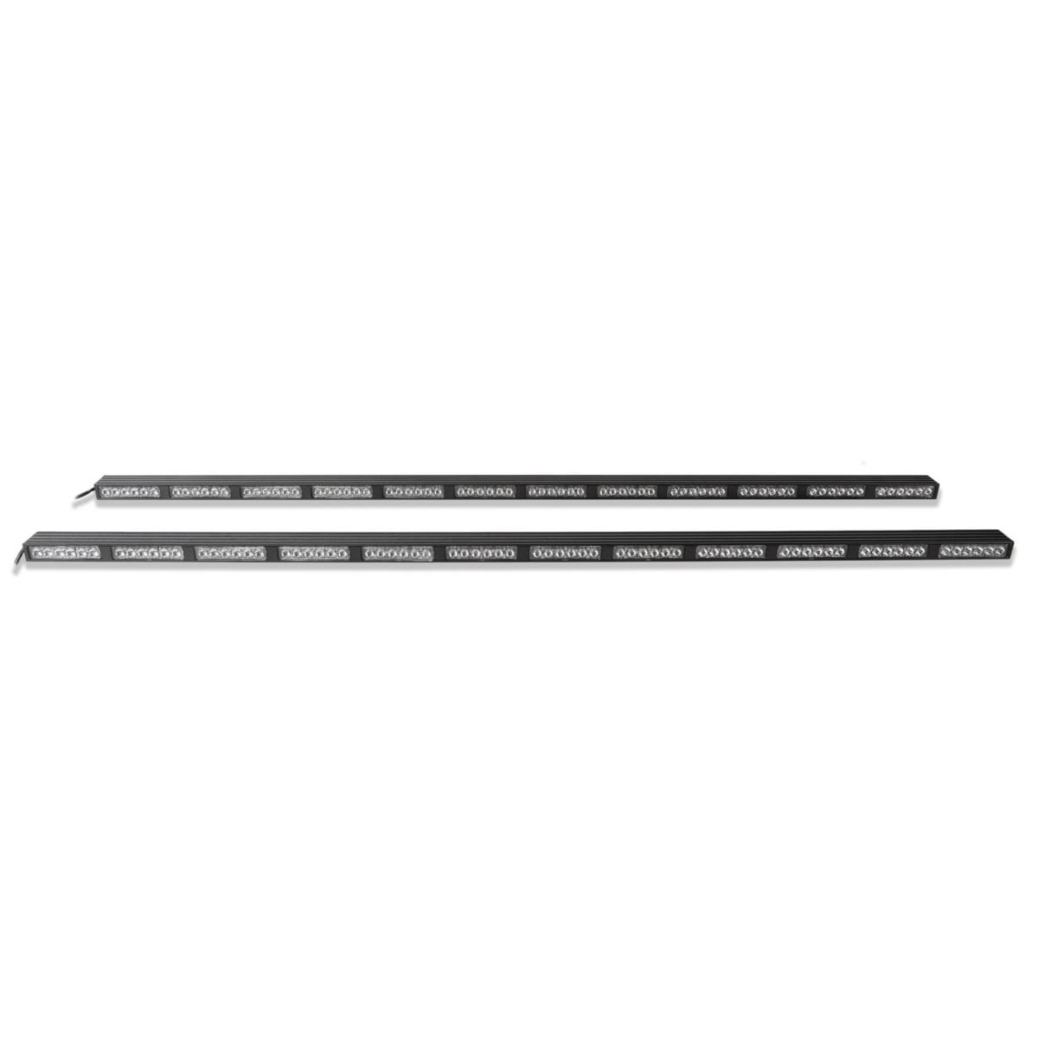

50 Inch, 60 Inch, and 70 Inch Models
NightHawk Series LED Running Board Lights

Operating Manual and Installation Instructions

Warnings and Notices for Users and Installers
WARNING: Take CAUTION when installing
This document must be delivered to and read by the end user and installer as it serves to provide you with the required information for proper and safe use of your LEDEQUIPPED product. Before operating this or any LEDEQUIPPED products the user and installer must read this manual all the way through. You will find important information in this manual that could prevent property damage and/or serious injury to the user and installer. LEDEQUIPPED products are intended to alert pedestrians and other operators of the presence of personnel, the operation of emergency vehicles, an emergency site, and any warning needs. It is your responsibility to make sure you can proceed safely before driving against traffic, entering an intersection, responding to a high rate of speed, or walking on or around traffic lanes.
Your LEDEQUIPPED emergency vehicle devices should be tested daily to insure the device and all it's functions are operating correctly. If you experience a malfunction contact LEDEQUIPPED's Customer Service immediately for troubleshooting options, or a warranty or service claim. You must ensure sure that the projection of the visual and audible is not blocked by vehicle components (i.e.: open trunks, visors, compartment doors), vehicles, other obstructions, or people. LEDEQUIPPED's sirens and other audible devices project sound in a forward direction and should be installed in a forward direction that faces away from the occupants of the vehicle.

This is professional grade equipment and is intended for strict use by authorized personal only. It is the user's responsibility to understand and obey all laws regarding emergency warning devices. You must know and be familiar with all applicable city, sate, and federal laws and regulations prior to the use of emergency vehicle warning devices. LEDEQUIPPED assumes no liability for any loss resulting from the use of this warning device. Proper installation is vital to the performance of the warning devices and safe operation of the emergency vehicle. Since the operator is under stressful environments the equipment must be properly wired and mounted to ensure effectiveness and safety. Therefore, controllers must be properly installed and placed within convenient reach of the operator so eye contact with the roadway is never lost. The effectiveness of your LEDEQUIPPED equipment is highly dependent upon correct mounting and wiring.

Improper wiring and mounting of the warning device will reduce the output and performance of the equipment. Emergency warning devices frequently require high electrical voltages and/or currents. Properly protect and use caution around live electrical connections. Grounding or shorting of electrical connections can cause high current arcing, which can cause severe personal injury and/or serious vehicle damage, including fire. Electromagnetic interference can be caused by many electronic devices used in emergency vehicles. To ensure that this doesn't happen to you, lights bars should be mounted a minimum of 12" - 34" from the radio antenna and do not power your equipment from the same circuit or share the same grounding circuit with radio communication equipment. After installation test all the vehicles equipment together to ensure everything operates free of interference. Driver and/or passenger airbags bags (SRS) will impact the way you mount your equipment. Any equipment installed in the deployment area of the airbags will damage or dislodge the airbags and sensors. This will also reduce the effectiveness of the airbags to protect the passengers and therefore these areas must be avoided. Installers must make sure that this equipment along with any parts, hardware, wiring, power supplies, and switch boxes do not interfere with the airbags, SRS wiring, or sensors. All LEDEQUIPPED equipment needs to be mounted and installed according to the vehicle manufactures instructions and securely attached to a part of the vehicle of sufficient strength to withstand the forces applied to the equipment. This device should be permanently mounted within the zones specified by the vehicle manufactures. This especially applies to equipment mounted on the exterior of the vehicle to avoid dislodging. When mounting units on the interior of the vehicle by a method other than permanent mount is discouraged as the it may become to detached under aggressive driving conditions such as sudden breaking, collision, or swerving.

Important Points for Your Safety and Longevity of your Equipment
Installers are required to have a good understanding of automotive electronic, systems and procedures for proper installation.
- One should not stare directly into the LEDs as momentary blindness and/or eye damage may occur.
- One should not take any lights through a car wash. Use only water to clean the outer body/lens of your equipment. –
- One should not use a pressure washer to clean any LEDEQUIPPED products. Inspect and test your product daily to insure it operates properly and is mounted correctly.
- One should not cut wires or work on a unit while the unit is still connected to a power source.
- One should not install this product or rout any wires through or in the deployment area of the airbag. Doing so may cause serious personal injury as it will damage or reduce the effectiveness of the airbag by causing the unit to become a projectile.
Reference the owner's manual for your vehicle to find the airbag deployment area. The User/Installer assumes all responsibility to determine proper mounting location, based on providing ultimate safety to all passengers in the vehicle.
- If the product requires you to drill holes the installer must ensure that the drilling process does not damage any vehicle components or other vital parts. Check all sides of the mounting surface before beginning to drill. Make sure to deburr all drilled holes and remove any metal remnants or shards to avoid injury and wires from becoming spliced. Grommets are to be installed in all wire passage holes.
- For LEDEQUIPPED products to operate at optimum efficiency a secure and good electrical connection to the Batteries Ground Post must be made. The recommended procedure requires the unit's ground wire be connected directly to the NEGATIVE (-) battery post.

Instructions for Wiring and Operation

Installation and Wiring
To ensure proper installation installers are required to have a good understanding of automotive electronic, systems and procedures for proper installation.
When you are drilling into the vehicle's surfaces, ensure that the area is free of any electrical wires, vehicle upholstery, fuel lines, etc. that could be damaged. All wiring passing through drilled holes should use grommets and silicone sealant to prevent wire or moisture damage when passing through compartment walls.
WARNING! Larger wires and secure or tight connections will ensure longer service life for your product. It is highly recommended that soldered connections have heat shrink used to protect the connection. Special attention should be given to the location and method of splicing wires to make electrical connections to protect these splices from lost power or connection and corrosion.
Insulation displacement connectors are not to be used. To reduce voltage drop, minimize the number of splices in the wires. The current carrying capacity of wires and fuses will be significantly reduced under high ambient temperature (e.g. under the hood).
All wires should be in accordance with the minimum wire size and other recommendations made by the manufacturer and be protected from hot surfaces and moving parts. Grommets, cable ties, looms, and other installation hardware should be used to anchor and protect all wiring. Fuses should be properly sized and located as close to the power take off points as possible to protect the wiring and device. To protect against short circuits, a fuse is included by LEDEQUIPPED for all products. Do NOT use a fuse with a higher amp rating than the initial fuse included.

Fig. 1

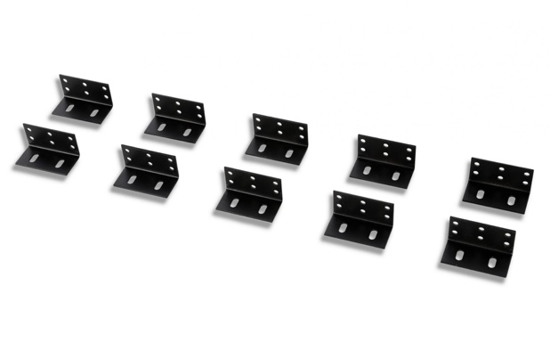

The NightHawk Series LED Running Board Lights may come with a prewired plug for use in a 12v auxiliary power outlet, however these are installed to facilitate bench testing your NightHawk Series LED Running Board Lights when they arrive and are typically removed for installation. In addition, the NightHawk Series LED Running Board Lights come with the appropriate number of two (2) inch ninety (90) degree L-Brackets as well as the appropriate number of 1 one (1) inch ninety (90) degree L-Brackets (not shown) for mounting directly into your vehicle (Fig. 1). Each installation is unique and therefore a variety of mounting brackets are included to allow for appropriate customization of your installation. Installation hardware is also included; however, many installers may choose to use stainless steel hardware for affixing the mounting brackets to your vehicle (not included). NightHawk Series LED Running Board Lights also have an optional White Cruise Mode which incorporates the ability to have the entire NightHawk Series LED Running Board Lights operate at a steady burn, when installed accordingly.

Installing the NightHawk Series LED Running Board Lights

It is recommended that you read this entire installation guide before you begin your specific installation. When unpacking your NightHawk Series LED Running Board Lights, ensure all of the installation components have been included, and it is suggested that you perform a bench test of your NightHawk Series LED Running Board Lights, using an appropriate 12v + (positive) power source, prior to beginning your specific installation.

It is necessary to identify the specific mounting location on your vehicle prior to beginning your installation. Some vehicles may have factory mounting locations that can be used for installation, however, this option will not be available for all vehicle types.

Once you have identified the specific vehicle mounting location for your installation, attach the included 90 degree L-Brackets to one of your NightHawk Series LED Running Board Lights, and space each bracket to fit your specific installation. Once you have identified the proper placement of the mounting brackets on your NightHawk Series LED Running Board Light, place the NightHawk Series LED Running Board Light, with the brackets, against the rocker panel where you will be mounting the light to ensure proper fit and spacing. Once you have ensured the fit and spacing of your mounting location, mark the areas where you will be attaching the L-Brackets to your vehicle, and remove the NightHawk Series LED Running Board Light. Please note that it is critical to ensure that your mounting location is free from any factory vehicle components or wiring prior to the installation of your NightHawk Series LED Running Board Lights and that mounting of your NightHawk Series LED Running Board Lights will not interfere or impede the safe operation of your vehicle. Damage to your factory vehicle components or wiring is at the installers sole and exclusive liability.

Many installers will find that using appropriately sized, self-tapping, stainless steel sheet metal screws (and washers if necessary) will facilitate the ease of installation of the NightHawk Series LED Running Board Lights, however the choice of mounting hardware that is used for each specific installation is at the installer’s sole and excusive discretion. Please note that because of the exposure to the elements that will occur in the external mounting of the NightHawk Series LED Running Board Lights, appropriate hardware should be used in the installation to prohibit hardware degradation or failure.

Once mounting locations and the appropriate mounting hardware has been selected, install each of the provided L-Brackets individually to your vehicle. Ensure that all hardware securing the provided L-Brackets to your vehicle have been tightened appropriately prior to affixing the NightHawk Series LED Running Board Lights to the L-Brackets. Begin attaching the NightHawk Series LED Running Board Lights using the front-most mounting bracket, then fasten the rear-most mounting bracket before attaching and securing the remaining mounting brackets.

Repeat the above procedures for the alternate side of the vehicle to complete the mounting of your NightHawk Series LED Running Board Lights. Once properly mounted and secured, proceed to wiring your NightHawk Series LED Running Board Lights for your specific installation.

Wiring the NightHawk Series LED Running Board Lights

The NightHawk Series LED Running Board Lights are fully encapsulated, weather and vibration resistant, and come configured with six (6) wires for ease of installation. Your NightHawk Series LED Running Board Lights may come with a prewired plug for use in a 12v auxiliary power outlet, however these are installed to facilitate bench testing your NightHawk Series LED Running Board Lights when they arrive and are typically removed for installation.

The NightHawk Series LED Running Board Lights are prewired to connect directly to an external switch box.

The prewired NightHawk Series LED Running Board Lights are designed to be hard wired to an optional external switch box according to the wiring specifications included in Figure 2 and Figure 3 below. Please note that the 12v + (Positive/Red Wires) and 12v – (Negative/Black Wires) wiring connections must be made to an appropriate 12v power source and ground in order for your NightHawk Series LED Running Board Lights to function properly. The image included in Figure 3 below provides a visual representation for how to wire the NightHawk Series LED Running Board Lights to your external switch box. LEDEQUIPPED manufactures several external switch boxes specifically designed to integrate effortlessly with the NightHawk Series LED Running Board Lights, as well as many additional optional accessories for your specific installation.

All wiring connections should be secured using appropriate automotive connectors or through the use of soldered connections. All connections should be protected by using heat shrink wire wrap in order to protect the connection. Special attention should be given to the location and method of splicing wires to make electrical connections to protect these splices from lost power or connection and corrosion.

Please note that both the Power On/Off wire (blue wire) and the 12v + (positive) wire (red wire) must be connected to an appropriate 12v + (positive) power source to operate your NightHawk Series LED Running Board Lights.

Fig. 2

NightHawk Series LED Running Board Lights
Wire Color | Function
Red | 12v + (Positive)
Black | 12v – (Negative)
Yellow | Flash Pattern Selection
Blue | Power On/Off
White | Synchronize
Green | Cruise Mode (Steady Burn)

Fig. 3 – Please note for illustrative purposes, the wiring should be configured appropriately to operate effectively with your preferred external switch box

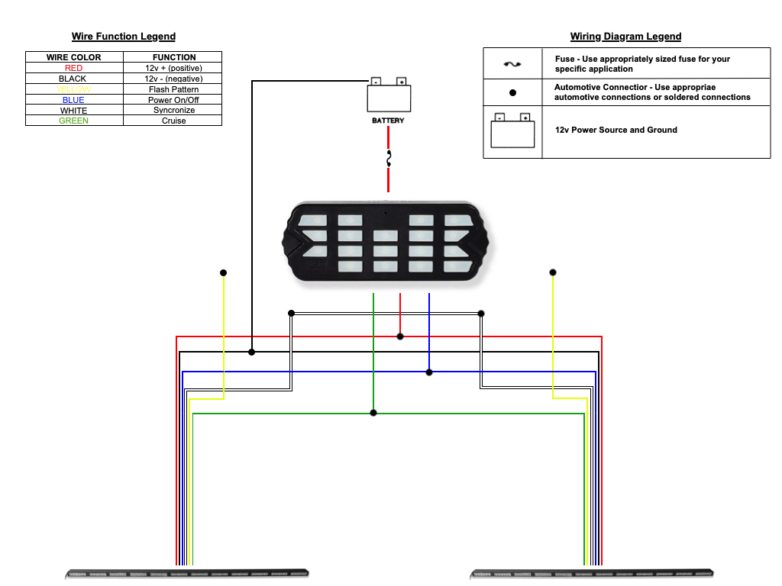

The NightHawk Series LED Running Board Lights have been designed for ease of installation and adaptation with limited additional wiring. This design allows for installers to create seamless integration of these units for your specific application.

In addition, the synchronization wire (white wire) that is included in the wiring bundle is used to sync each of the NightHawk Series LED Running Board Lights units to operate in tandem. Simply connecting the synchronization wires (white wires) of each unit together provides for effortless synchronization.

Operating Your NightHawk Series LED Running Board Lights
Flash Pattern Selection
All LEDEQUIPPED lights are equipped with non-volatile memory which will recall the last selected flash pattern when turned on. Selecting the preferred flash pattern is easily done by touching the yellow flash pattern selection wire to an appropriate 12v + (positive) power source. Because of the paired installation of the NightHawk Series LED Running Board Lights, many installations desire to have both sides flashing in a synchronized pattern. To ensure that the flash patterns are synced, wire the synchronization wires (white wire) from each NightHawk Series LED Running Board Light together. This will synchronize the flash patterns for both NightHawk Series LED Running Board Lights. In addition, to ensure that pattern changes are made on both NightHawk Series LED Running Board Lights, it is necessary to wire the pattern selection wires (yellow wires) together from both NightHawk Series LED Running Board Lights . Once powered on and wired in accordance with these instructions, it will be necessary to reset both NightHawk Series LED Running Board Lights to the same flash pattern. This can be done by applying the bundled pattern selection wires (yellow wires) from both NightHawk Series LED Running Board Lights to an appropriate 12v + (positive) power source for approximately three (3) seconds Each light head will momentarily turn off, and then return to the first available flash pattern. Applying the bundled pattern selection wires (yellow wires) from both NightHawk Series LED Running Board Lights to an appropriate 12v + (positive) power source momentarily will advance the to the next available flash pattern. Please see Figure 4 below for a listing of the preconfigured flash patterns for your NightHawk Series LED Running Board Lights.
Fig. 4

NightHawk Series LED Running Board Flash Patterns
Pattern  Number | Function | Pattern  Number | Function
1 | Quad Burst – Split | 9 | Quad/Single with Quad Burst – Split
2 | Quad Burst – All | 10 | Quad/Single with Quad Burst – All
3 | Quad – Split | 11 | Accelerator - Split
4 | Quad – All | 12 | Accelerator – All
5 | Super Flash – Split | 13 | Express Flash
6 | Super Flash – All | 14 | Steady Burn - All (Cruise Mode)
7 | Quad/Single with Quad Burst – Split | 15 | Off
8 | Quad/Single with Quad Burst – All

Cruise Mode
The optional NightHawk Series LED Running Board Lights, with optional White Cruise Mode, are preconfigured to allow for an on demand steady burn (cruise) pattern selection when activated, to allow for additional visibility along the side of your vehicle when needed. This option allows your NightHawk Series LED Running Board Lights to operate at a white steady burn, regardless of the operating colors of your light bar, when so configured. It is recommended that a separate switch or button is used on your lighting control box to power the cruise mode for individualized use of this functionality. To wire the cruise mode, connect the cruise mode wires from each light head together and connect the bundled cruise mode wires (green wires) to a 12v + (positive) power source. When connected to a 12v + (positive) power source, cruise mode on your NightHawk Series LED Running Board Lights will become activated.

In addition to the optional White Cruise Mode, all NightHawk Series LED Running Board Lights can be operated in the same manner for an on demand steady burn (cruise) pattern selection when activated. Regardless of the option for the optional White Cruise Mode, connecting the bundled cruise mode wires (green wires) to a 12v + (positive) power source, steady burn (cruise mode) on your NightHawk Series LED Running Board Lights will become activated. As with the optional White Cruise Mode, it is recommended that a separate switch or button is used on your lighting control box to power the cruise mode for individualized use of this functionality.

NightHawk Series LED Running Board Lights Optional Accessories

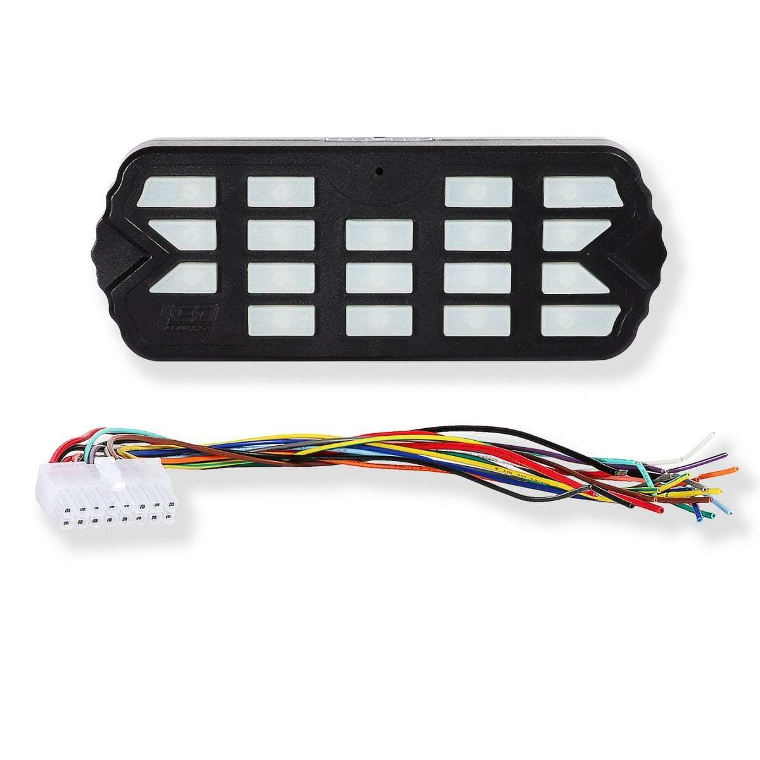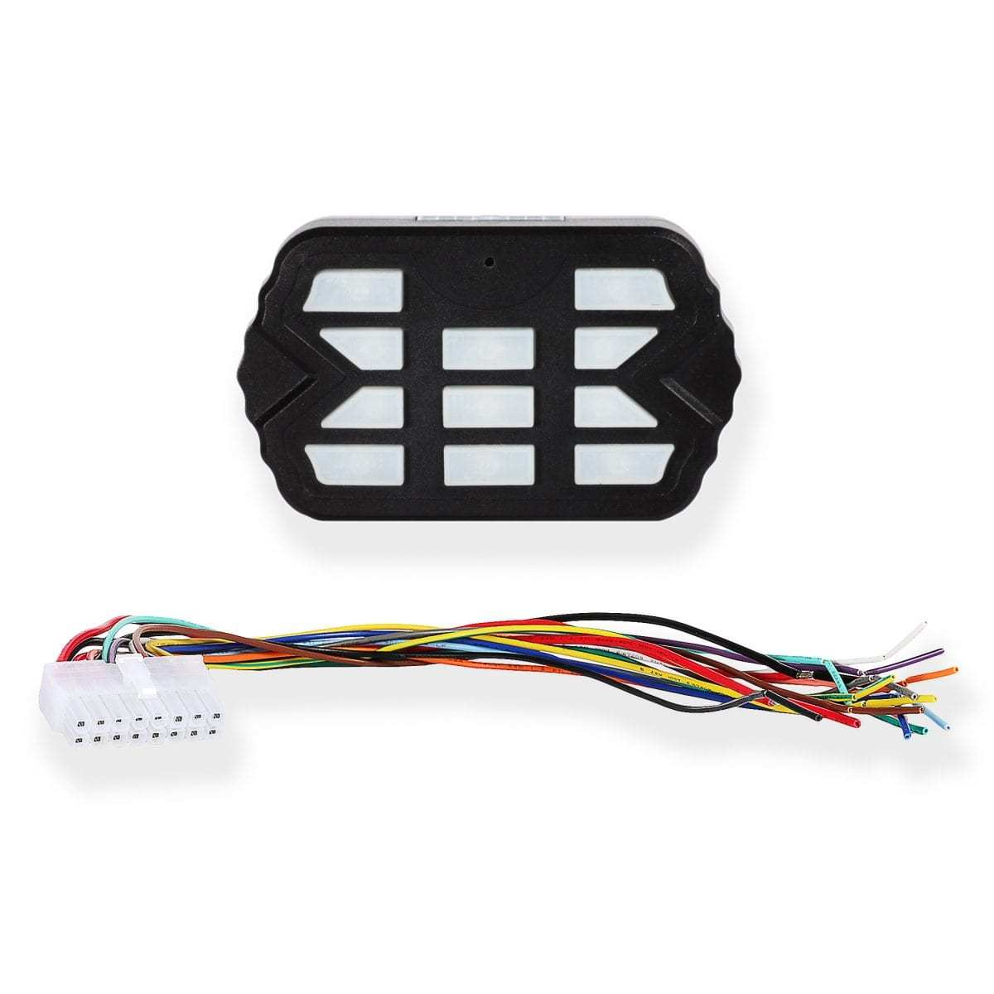
Combat Controller  Product Number: A-1516 | Combat Mini Controller  Product Number: A-1515
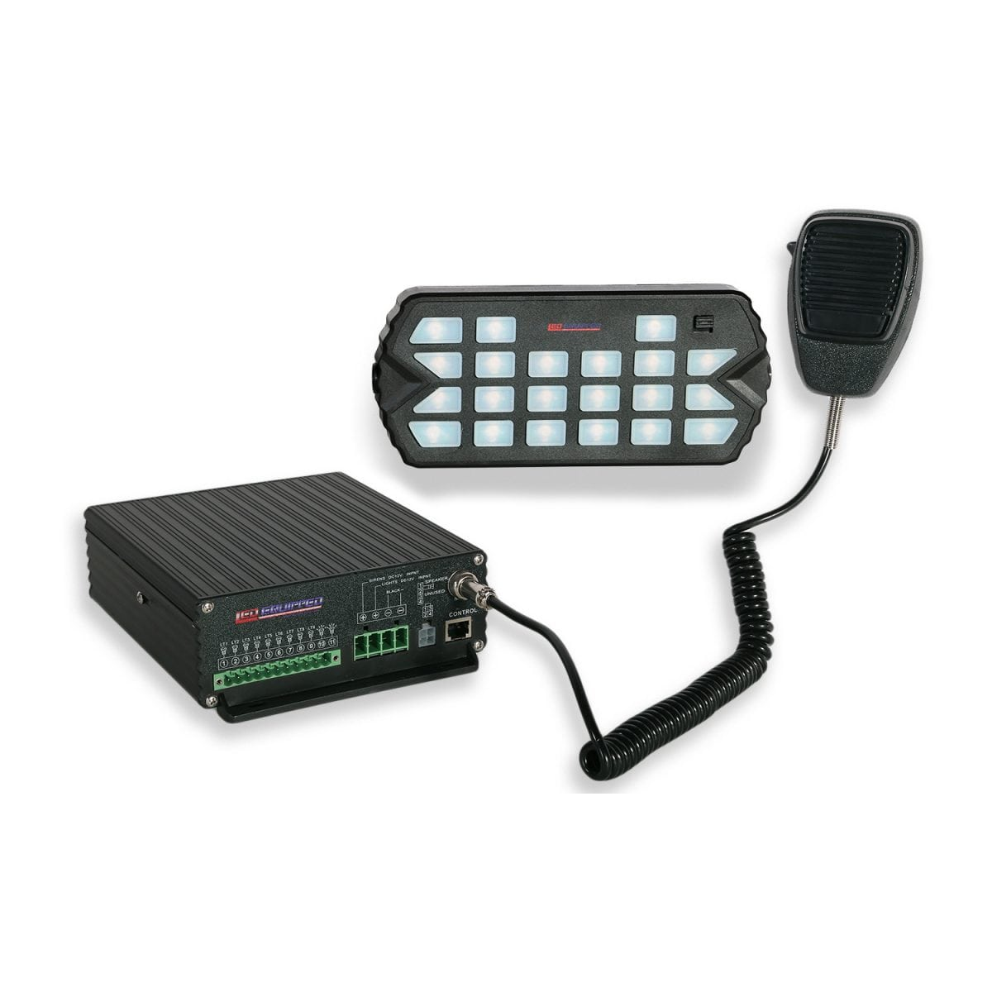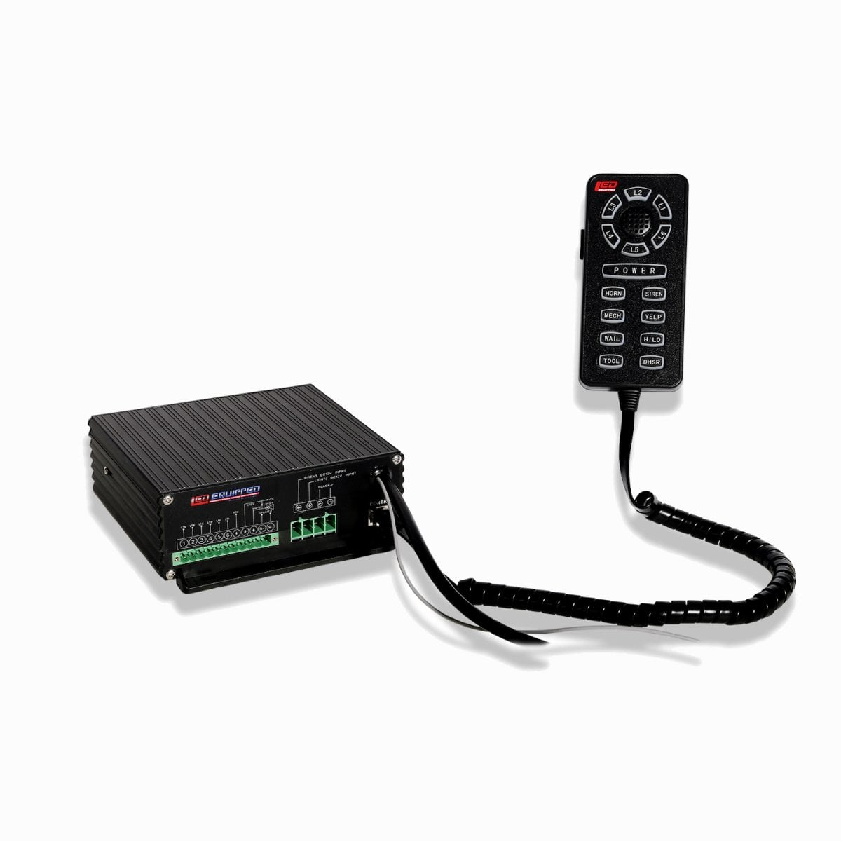
Black Falcon Siren and Control Unit  Product Number: A-1237 (100w) and  A-1368 (200w) | Pelican Siren and Control Unit  Product Number: A-1108 (100w) and  A-1109 (200w)

At LEDEQUIPPED, we know that you need affordable lighting for your police, EMS, fire, construction, or towing vehicles and that safety and reliability are important to you. That’s why all of our LED products feature powerful up do date Generation LED lighting, perfect for your police, fire, construction, or EMS vehicle. LEDEQUIPPED focuses on a mission to carry out business ethically and with integrity, provide powerful products of the highest quality, maintain excellent and affordable prices, and to establish an unparalleled customer service relationship beginning with establishing trust with our customers. As a provider of emergency vehicle lighting, we value the honesty, professionalism, and expertise present within our customer base
For any questions regarding our products, contact us by calling us at +1 800-846-3940 or email us at sales@ledequipped.com.

