#### Operation Manual and Instructions

**Warnings and Notices for Users and Installers WARNING: Take CAUTION when installing**

This document must be delivered to and read by the end user and installer as it serves to provide you with the required information for proper and safe use of your LEDEQUIPPED product. Before operating this or any LEDEQUIPPED products the user and installer must read this manual all the way through. You will find important information in this manual that could prevent property damage and/or serious injury to the user and installer. LEDEQUIPPED products are intended to alert pedestrians and other operators of the presence of personnel, the operation of emergency vehicles, an emergency site, and any warning needs. It is your responsibility to make sure you can proceed safely before driving against traffic, entering an intersection, responding to a high rate of speed, or walking on or around traffic lanes.

Your LEDEQUIPPED emergency vehicle devices should be tested daily to insure the device and all it's functions are operating correctly. If you experience a malfunction contact LEDEQUIPPED's Customer Service immediately for troubleshooting options, or a warranty or service claim. You must ensure sure that the projection of the visual and audible is not blocked by vehicle components (i.e.: open trunks, visors, compartment doors), vehicles, other obstructions, or people. LEDEQUIPPED's sirens and other audible devices project sound in a forward direction and should be installed in a forward direction that faces away from the occupants of the vehicle.

This is professional grade equipment and is intended for strict use by authorized personal only. It is the user's responsibility to understand and obey all laws regarding emergency warning devices. You must know and be familiar with all applicable city, sate, and federal laws and regulations prior to the use of emergency vehicle warning devices. LedEquipped assumes no liability for any loss resulting from the use of this warning device. Proper installation is vital to the performance of the warning devices and safe operation of the emergency vehicle. Since the operator is under stressful environments the equipment must be properly wired and mounted to ensure effectiveness and safety. Therefore, controllers must be properly installed and placed within convenient reach of the operator so eye contact with the roadway is never lost. The effectiveness of your LEDEQUIPPED equipment is highly dependent upon correct mounting and wiring.

Improper wiring and mounting of the warning device will reduce the output and performance of the equipment. Emergency warning devices frequently require high electrical voltages and/or currents. Properly protect and use caution around live electrical connections. Grounding or shorting of electrical connections can cause high current arcing, which can cause severe personal injury and/or serious vehicle damage, including fire. Electromagnetic interference can be caused by many electronic devices used in emergency vehicles. To ensure that this doesn't happen to you, lights bars should be mounted a minimum of 12" - 34" from the radio antenna and do not power your equipment from the same circuit or share the same grounding circuit with radio communication equipment. After installation test all the vehicles equipment together to ensure everything operates free of interference. Driver and/or passenger airbags bags (SRS) will impact the way you mount your equipment. Any equipment installed

in the deployment area of the airbags will damage or dislodge the airbags and sensors. This will also reduce the effectiveness of the airbags to protect the passengers and therefore these areas must be avoided. Installers must make sure that this equipment along with any parts, hardware, wiring, power supplies, and switch boxes do not interfere with the airbags, SRS wiring, or sensors. All LEDEQUIPPED equipment needs to be mounted and installed according to the vehicle manufactures instructions and securely attached to a part of the vehicle of sufficient strength to withstand the forces applied to the equipment. This device should be permanently mounted within the zones specified by the vehicle manufactures. This especially applies to equipment mounted on the exterior of the vehicle to avoid dislodging. When mounting units on the interior of the vehicle by a method other than permanent mount is discouraged as the it may become to detached under aggressive driving conditions such as sudden breaking, collision, or swerving.

#### Important Points for Your Safety and Longevity of your Equipment –

Installers are required to have a good understanding of automotive electronic, systems and procedures for proper installation.

* One should not stare directly into the LEDs as momentary blindness and/or eye damage may occur.
* One should not take any lights through a car wash. Use only water to clean the outer body/lens of your equipment. –

One should not use a pressure washer to clean any LEDEQUIPPED products. Inspect and test your product daily to insure it operates properly and is mounted correctly.

* One should not cut wires or work on a unit while the unit is still connected to a power source.
* One should not install this product or rout any wires through or in the deployment area of the airbag. Doing so may cause serious personal injury as it will damage or reduce the effectiveness of the airbag by causing the unit to become a projectile.

Reference the owner's manual for your vehicle to find the airbag deployment area. The User/Installer assumes all responsibility to determine proper mounting location, based on providing ultimate safety to all passengers in the vehicle.

* If the product requires you to drill holes the installer must ensure that the drilling process does not damage any vehicle components or other vital parts. Check all sides of the mounting surface before beginning to drill. Make sure to deburr all drilled holes and remove any metal remnants or shards to avoid injury and wires from becoming spliced. Grommets are to be installed in all wire passage holes.
* For LEDEQUIPPED products to operate at optimum efficiency a secure and good electrical connection to the Batteries Ground Post must be made. The recommended procedure requires the unit's ground wire be connected directly to the NEGATIVE (-) battery post.

#### Instructions for Mounting, Wiring and Programming

To ensure proper installation installers are required to have a good understanding of automotive electronic, systems and procedures for proper installation.

When you are drilling into the vehicle's surfaces, ensure that the area is free of any electrical wires, vehicle upholstery, fuel lines, etc. that could be damaged. All wiring passing through drilled holes should use grommets and silicone sealant to prevent wire or moisture damage when passing through compartment walls.

WARNING! Larger wires and secure or tight connections will ensure longer service life for your product. It is highly recommended that soldered connections have heat shrink used to protect the connection. Special attention should be given to the location and method of splicing wires to make electrical connections to protect these splices from lost power or connection and corrosion.

Insulation displacement connectors are not to be used. To reduce voltage drop, minimize the number of splices in the wires. The current carrying capacity of wires and fuses will be significantly reduced under high ambient temperature (e.g. under the hood).

All wires should be in accordance with the minimum wire size and other recommendations made by the manufacturer and be protected from hot surfaces and moving parts. Grommets, cable ties, looms, and other installation hardware should be used to anchor and protect all wiring. Fuses should be properly sized and located as close to the power take off points as possible to protect the wiring and device. To protect against short circuits, a fuse is included by LedEquipped for all products. Do NOT use a fuse with a higher amp rating than the initial fuse included.

### INSTALLATION AND CONFIGURATION MANUAL LEDEQUIPPED GROWLER LOW F REQUENCY SIREN SYSTEM

**WIRING AND FUNCTION**

#### WARNING:

**FIRE HAZARD**

If shorted to the vehicle frame, high current conductors can cause hazardous sparks resulting in electrical fires.

DO NOT connect this system to vehicle battery until ALL other electrical connections are made and mounting of all components is complete. Verify that no short circuits exist before connecting to thepositive (+) battery terminal.

Failure to follow this warning can cause a fire and may result in serious injury or death to you or others.

**DRILLING PRECAUTIONS**

Before drilling holes, check the area into which you plan to drill to ensure you do not damage vehicle components while drilling. All drilled holes should be de-burred and all sharp edges should be smoothed. All wires going through drilled holes should be protected by a grommet or convolute/split-loom tubing.

#### Connecting the Input Leads CONNECT INPUT LEADS PROPERLY

Failure to connect the input leads could result in damage to the vehicle's main emergency siren.

## Q1==========l Q

**BROWN & WHITE ZIP CORD**

**BROWN GREEN & WHITE ZIP CORD**

#### GROWLER SPEAKERS

**HORN RING OR MOMENTARY SWITCH**

Q1==========l Q

**RED+**

**BLACK-**

**BATTERY CUT WIRE**

#### MAIN SIREN AMPLIFIER

**MAIN SIREN SPEAKERS**

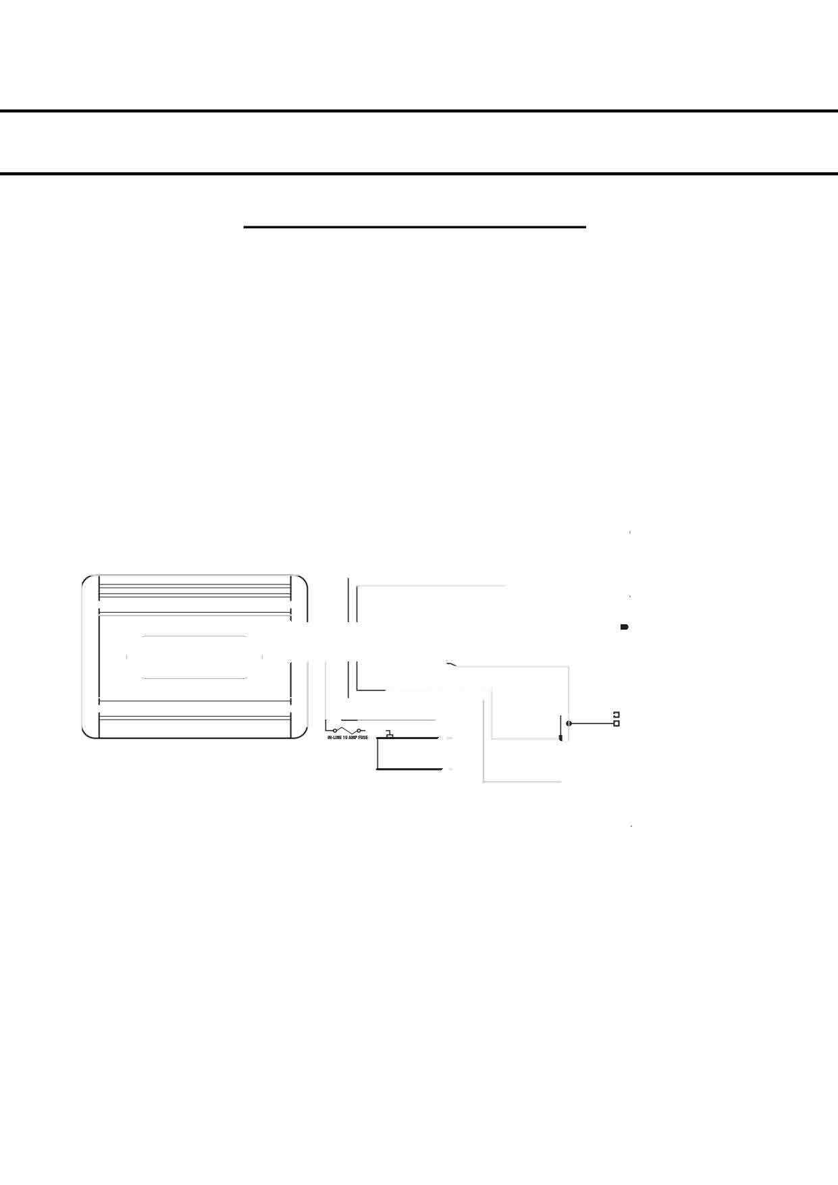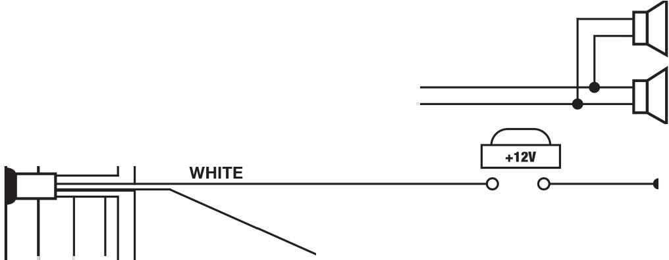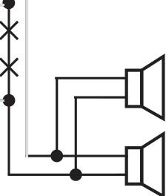

Use 18 AWG wire to connect the output leads (brown & white attached together) in series with both of the Growler speaker leads. You will find 2 plugin leads with black and white wire attached, please wire the brown wire to both blacks and the white wire to both whites and plug into the woofers

Use 18 AWG wire to connect the input leads (green & white zip cord) in series with one of the speaker leads of the emergency vehicle's main siren. To elaborate, cut the ground wire ground from the siren amp to siren speaker, 1 half will connect to the green wire and the other half to the white wire, creating the circulation in the woofer amp.

Use 18 AWG wire to connect the brown input lead to the other speaker lead of the emergency vehicle's main siren. To elaborate, wire this into the postivie wire going from your siren amp to your speaker

#### Connecting the Activation Input

Use 22 AWG wire to connect the white activation lead to the vehicle's horn ring circuit or user supplied momentary switch.

**NOTE:** The Growler only activates by placing the white activation lead to 12-Volt. If activation is required from a ground signal, an installer-supplied relay Module must be used. The ground signal will energize the relay, and the relay contact will place the white activation lead to 12-Volt.

**INSTALLATION AND CONFIGURATION MANUAL LEDEQUIPPED Growler LOW F REQUENCY SIREN SYSTEM**

**WIRING AND FUNCTION**

#### Connecting Power

The Growler operates only from 12-Volt NEGATIVE-grounded vehicle electrical system. Therefore, before making any electrical connections, determine the polarity of the vehicle's electrical system ground.

### BATTERY DRAIN

The Growler system does not have an on-off switch. If power for the Growler is obtained directly from the vehicle battery, it draws approximately 0.20 Ah per day in standby mode. If you are connecting the Growler to the switched side of the ignition circuit, make sure the circuit has enough current capacity to handle the additional 10 A (approx.) load.

#### FUSE AMPLIFIER AT 12 V SOURCE

Damage to the Growler will occur if it is not properly fused. Ensure that the supplied in-line fuse holder and 15 A fuse are installed in the red power lead. The Growler should also be fused witha user supplied 15 A fuse at the 12-volt source.

* 1. Use a 14 AWG or heavier wire to connect the amplifier's black ground lead to the vehicle battery's negative terminal (-NEG) or ground lug.
  2. Use a 14 AWG or heavier wire to connect the amplifier's red lead to the selected 12-volt source.

#### SOUND HAZARD

The Growler increases close-proximity warning effectiveness by generating siren signals that better penetrate a vehicle's interior. These signals also may increase sound levels in the operator's vehicle, and may increase noise exposure to the operator. The amount of this increase will vary based upon the length of time operators are exposed to noise from emergency operation, the vehicle in which the Growler is installed, and other factors.

The amplifier 's 8-60 second timer is factory-set for a default time of 8 seconds. After assessing sound levels in the operators' compartment, you must adjust the timer on the interface board inside the amplifier to limit the operating time of the amplifier based upon the expected usage through a work shift. You should also be sure your operators heed all other warnings associated with the use of sirens, and provide and require the use of hearing protection, if appropriate, based on your particular exposure levels and conditions of use. If you operate the Growler before you can make an assessment of operator noise exposures, set it for the shortest amount of time possible and require the use of hearing protection devices.

***Failure* to *follow this warning may result in hearing damage* to *operators and passengers.***

#### Setting the 8-60 Second Timer

**To set the timer:**

1. Locate the slot on the back side of the Growler Amplifier.

ROTARY LEDS

# e101010

DIPSW

8 SECONDS

# e :010

37 SECONDS

1. Rotate the rotar y dip switch until the LED indicator

e10101 � 15 SECONDS

e :01 � 45 SECONDS

displays the desired time interval. e :



1. Activate the vehicle's main siren and the Growler.

e J

1. Check the sound exposure time and make further adjustments, if necessar y.

# e101

1o1 1 30 SECONDS

e : 1 �60 SECONDS

### INSTALLATION AND CONFIGURATION MANUAL LEDEQUIPPED GROLWER LOW F R EQUENCY SIR EN SYST EM

**INSTALLING BRACKETS**

#### Mounting the Speakers

**NOTE:** Before drilling holes in ANY part of the vehicle, ensure that both sides of the surfaceare clear of parts that could be damaged; such as brake lines, fuel lines, electrical wiring or other vital parts.

1. To mount the speakers locate a suitable position for bracket to be mounted.
2. Using the mounting bolts supplied with the speaker, attach the mounting bolts to the mounting bracket then mounting surface as shown in Figure 1.
3. Separate the bands and slide the GROWLER speaker into place. The domed end of the speaker should be towards the engine. Ensure the slots are facing the sides. see figure 2.
4. Secure the speaker in the mounting brackets using the mounting bolts supplied with the speaker.
5. Repeat steps 1 through 4 for the alternate side.

7. When the installation is completed, test the siren system for proper operation.

### FIGURE 1:

**MOUNTING BOLTS -----+ MOUNTING SURFACE -----+**

### FIGURE 2:

**MOUNTING SURFACE**

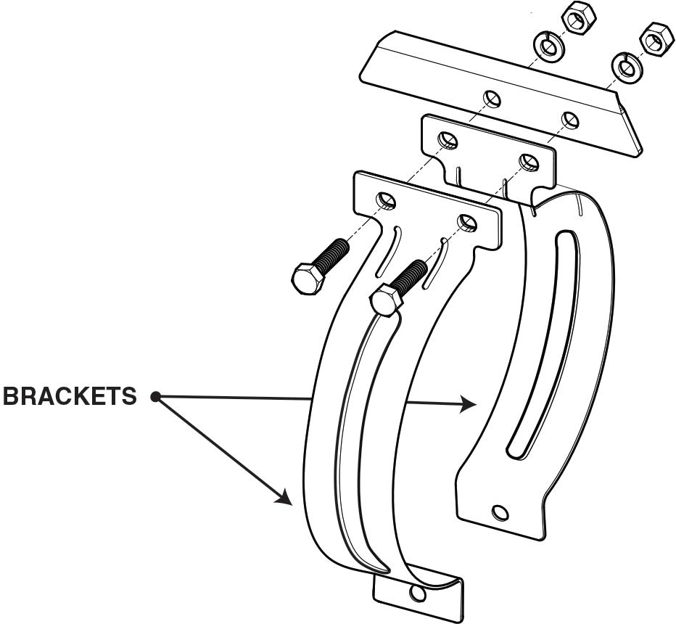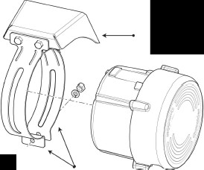

**MOUNTING BOLTS**

*(/*

/

**BRACKETS**